**DIRECT SEQUENCE SPREAD SPECTRUM(DSSS)**

In digital communication systems, the design of baseband pulse-shaping and modulation techniques aims to minimize the amount of bandwidth consumed by the modulated signal during transmission. Spread spectrum technologies were initially developed for the military communities to overcome the two aforementioned shortcomings against interception and jamming. The basic idea was expand to each user signal to occupy a much broader spectrum than necessary.

Spread spectrum is a technique whereby an already modulated signal is modulated a second time in such a way as to produce a waveform which interfaces in a barely noticeable way with any other signal operating in the same frequency band. Thus, a receiver turned to receiver specific AM or FM broadcast would probably not notice the presence of a spread spectrum signal operating over the same frequency band.

There are two dominant spread spectrum technologies:

1. Frequency Hopping Spread Spectrum(FHSS)
2. Direct Sequence Spread Spectrum(DSSS)

A direct sequence spread spectrum (DS-SS) signal is one in which the amplitude of an already modulated signal is amplitude modulated by a very high rate NRZ binary stream of digits.

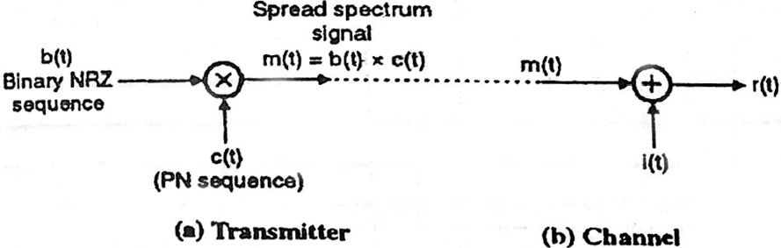

(Block Diagram of Direct Sequence Spread Spectrum)

In DS-SS system the information signal, b(t) is multiplied by a wideband code signal c(t), which is the output of the signal of the direct sequence generator. The signal b(t) * c(t) = m(t) is modulated and trans mitted. This signal occupies a bandwidth required to transmit the information signal b(t).

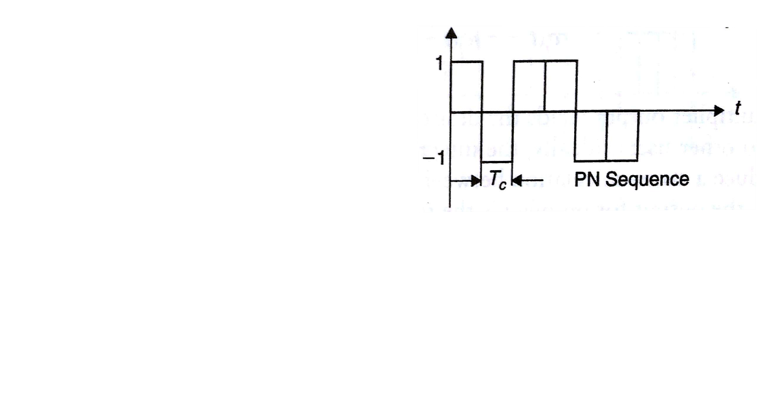

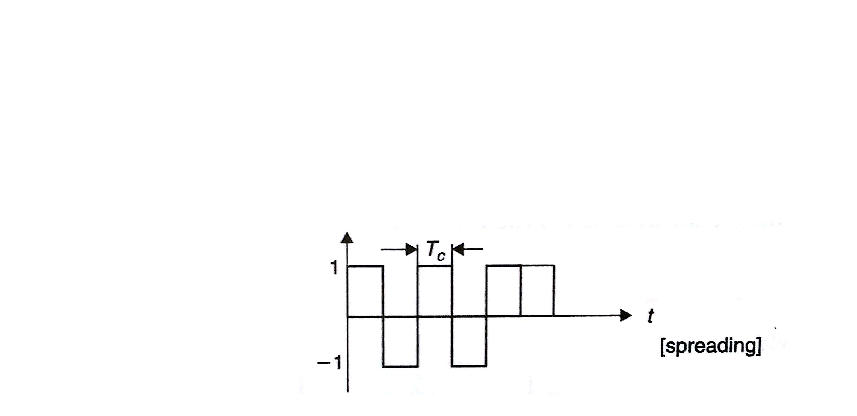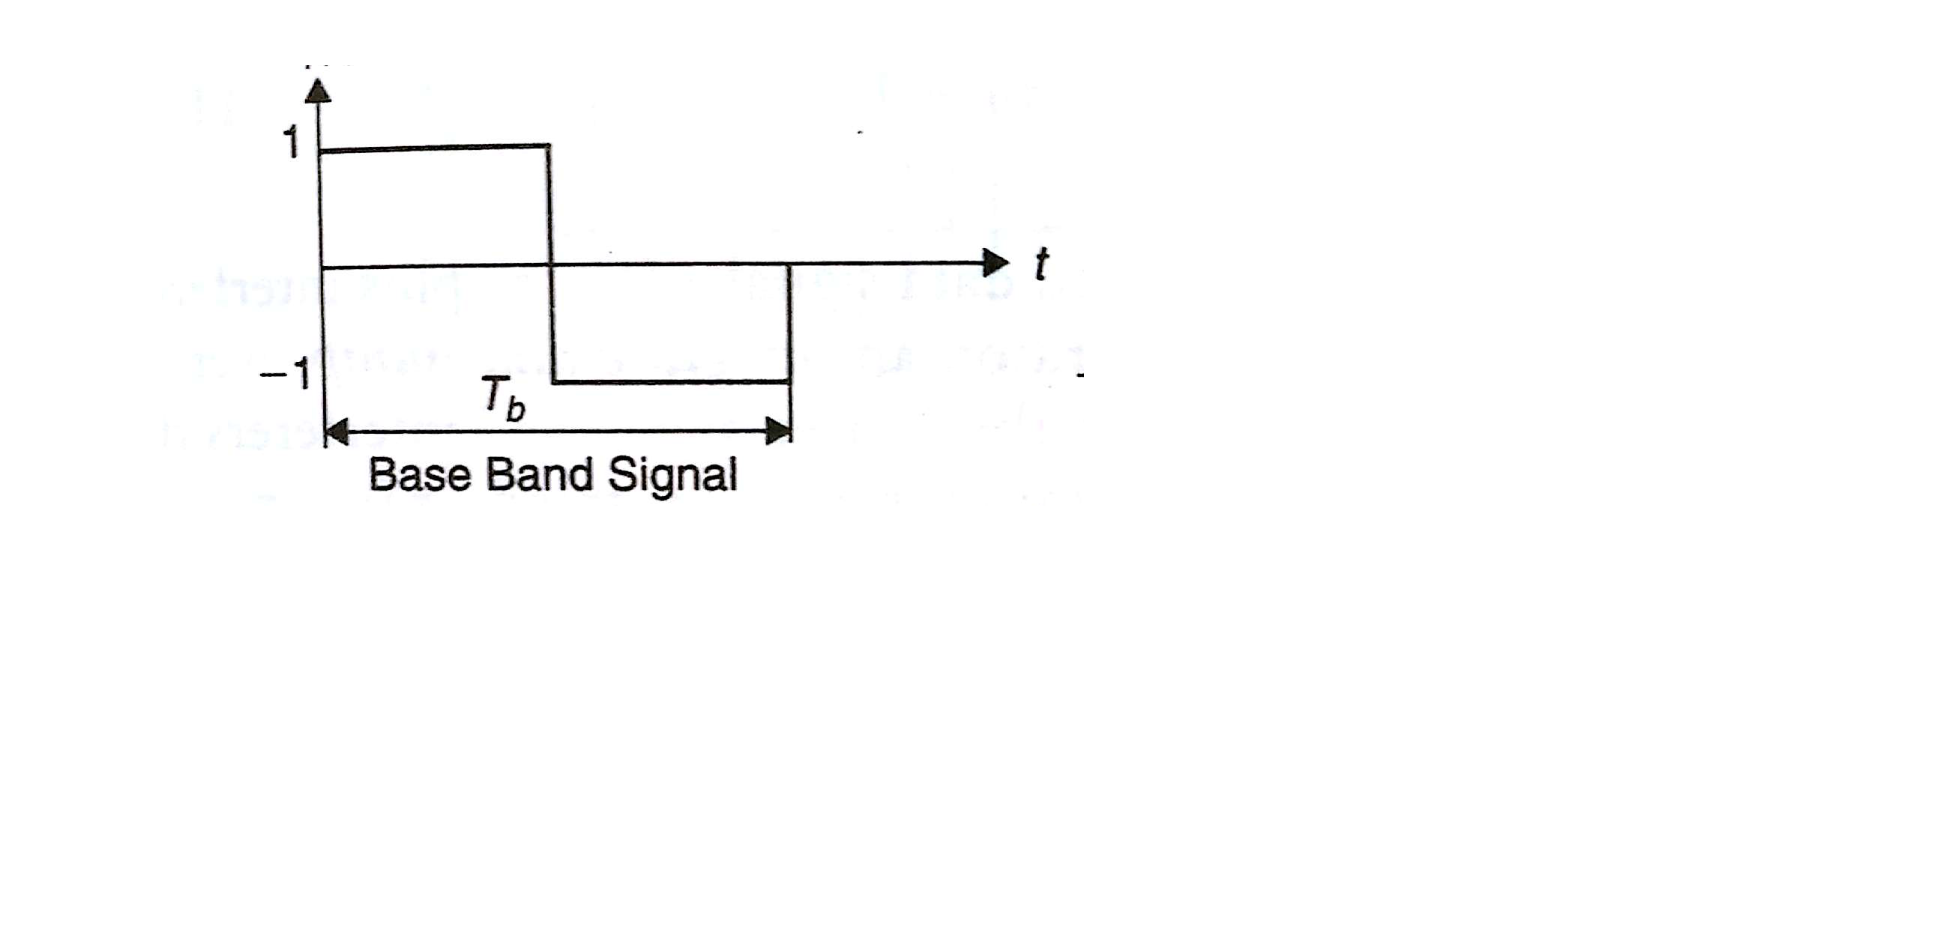

**CODE**

clc;

close all;

clear all;

x=input('Enter The input Bits : ');

b=randi([0,1],x);

len=length(b);

%to get NRZ data bit 0 to -1 is converting

for i=1:len

if b(i)==0

b(i)=-1;

end

end

k=1;

% Generating the bit sequence of 6 samples

for i=1:len

for j=1:6

b1(k)=b(i);

j=j+1;

k=k+1;

end

i=i+1;

end

len1=length(b1);

subplot(2,1,1);

stairs(b1,'linewidth',2);

axis([0 len1 -2 3]);

title('ORIGINAL BIT SEQUENCE b(t)');

% Generating the pseudo random sequence

c=round(rand(1,len1));

for i=1:len1

if c(i)==0

c(i)=-1;

end

end

subplot(2,1,2);

stairs(c,'linewidth',2);

axis([0 len1 -2 3]);

title('PSEUDORANDOM SEQUENCE c(t)');

% Multiplying data bit with Pseudo random Sequence

for i=1:len1

b2(i)=b1(i).*c(i);

end

% Modulating the multiplyed signal

dsss=[];

t=0:1/10:2*pi;

m1=cos(t);

m2=cos(t+pi);

for k=1:len1

if b2(1,k)==-1;

dsss=[dsss m1];

else

dsss=[dsss m2];

end

end

figure

subplot(2,1,1);

stairs(b2,'linewidth',2);

axis([0 len1 -2 3]);

title('MULTIPLIER OUTPUT SEQUENCE b(t)*c(t)');

subplot(2,1,2);

plot(dsss);

axis([0 1000 -1 1]);

title(' DS-SS SIGNAL');

**OUTPUT**

Enter The input Bits : 10

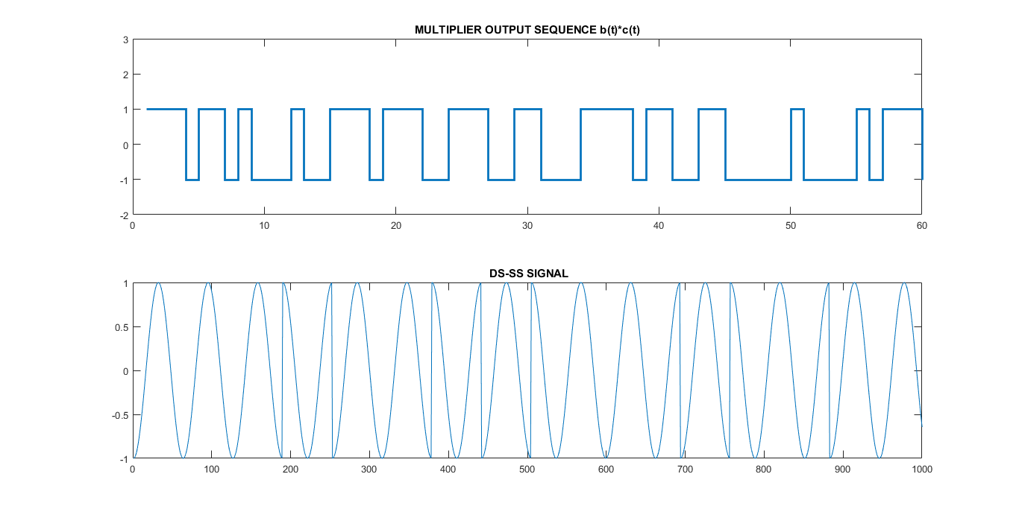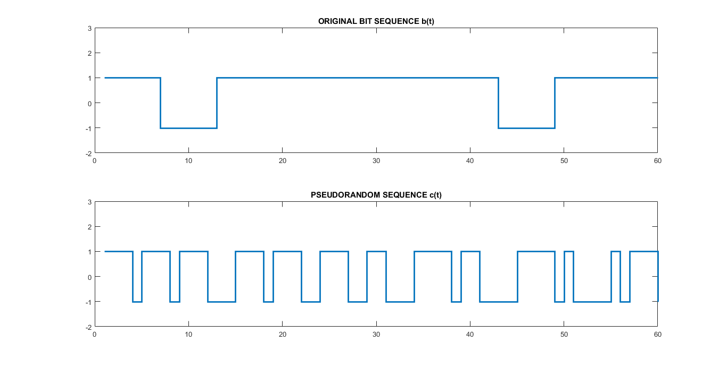

**EXPLANATION**

* The input data sequence is denoted by x(t). This data sequence is first converted into an NRZ sequence b(t) by the NRZ encoder.
* The NRZ signal b(t) and the pseudorandom signal c(t) are applied to the two inputs of a product modulator.
* At the output of the product modulator, we obtain the spread spectrum signal. The spectrum of this signal is quite spread out as compare to the spectrum of b(t) which is a narrow band signal.
* Thus a data sequence b(t) is used to modulate a wideband pseudorandom noise sequence c(t) by applying these two sequences to the multiplier.
* Hence if the data sequence b(t) is narrow band and the PN sequence c(t) is a wideband sequence, then the product sequence m(t) = b(t) * c(t) will have a spectrum M(f) which will be nearly the same as that of PN sequence c(t).
* Thus the narrow band signal b(t) will be spread over the wideband and the PN sequence performs the role of a spreading code.

**REFERENCES**

1. Taub’s PRINCIPLE OF COMMUNICATION SYSTEM by Herbart Taub, Donald Schilling & Goutam Saha (4th edition)
2. WIRELESS COMMUNICATIONS AND NETWORKS by Vijay K. Garg
3. MODERN DIGITAL AND ANALOG COMMUNICATION SYSTEMS by B.P. Lathi & Zhi Ding (Indian Edition(4th Internationa))